What is BACK.finance

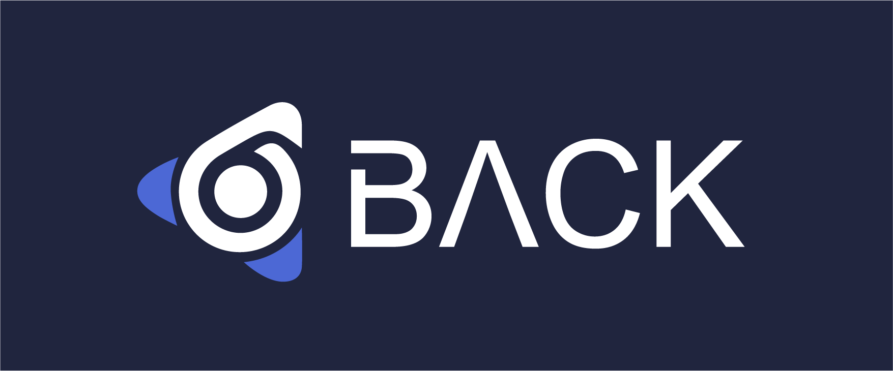

BACK is a decentralized smart contract for leveraged borrowing and lending released by [BACK.FINANCE](https://back.finance/" \t "_blank). It enables users to maximize their returns by providing up to 3x leverage.

Users who prefer more stable returns can lend their assets to yield farmers and earn interests.

This innovative product aims to answer to the Defi needs from users of all types while providing the best-in-class user experience.

* Users who lend, borrow and deposit cryptos in BACK will be rewarded with BACK tokens.

**Yield farmer**

Yield farmers can earn high returns from taking on leveraged yield farming positions. Of course, higher returns bring higher risks including liquidation risk, short-term loss and etc.

**Leveraged mining**: Once users select a pool, they can farm by supplying two assets at any ratio to the pool and specifying the desired crypto to borrow and the leverage to farm. A quick example: the user provides ETH/USDT at any ratio to ETH/USDT pool and chooses USDT as the crypto to borrow. Then BACK will automatically and optimally swap the tokens in Mdex or other platforms to ensure that the ratio of the tokens participating in yield farming is the same as that of the pool.

**Auto staking**: BACK will automatically stake LP token to get MDX and other platform tokens.

**Reinvestment welcomed**: BACK encourages users to reinvest MDX and other farmed tokens to further increase token rewards.

**High debt ratio**: Liquidation takes place when debt ratio (debt/position value) exceeds liquidation debt ratio.

* To avoid any liquidation loss, please refill your position once its health mark is in the red zone.

**Adjustable positions**：users can at any time add more tokens.

* Currently, only when users withdraw assets can they have their principals back.

**Lenders**

Lenders earn returns by depositing their funds into BACK’s deposit pool. The deposited funds will be provided to yield farmers to increase their positions.

**Interest-bearing token (bk Token)**: When users deposit ETH/USDT/HUSD to BACK deposit pool, they receive a proportional amount of bk Token, a tradable and interest-bearing asset that represents their shares in the deposit pool.

**Earn Interest**: Interest paid by borrowers are distributed to lenders, proportionate to the amount lent. Lenders' interest rate depends on fund utilization rate; the higher the utilization, the higher the interest rate.

Notes:[Borrower's interest rate model follows slope curve](/back-finance/v/en/xie-yi/interest" \l "ping-tai-cun-jie-kuan-li-lv)

10% of borrower's interest will go into BACK Reserves.

* Users who deposit cryptos in BACK will be rewarded with BACK tokens.

**Liquidators**

Liquidators closely monitor the debt ratio of the positions in the liquidity pool. Liquidation takes place when excessive debt ratio is spotted and liquidators can earn bonuses for liquidating positions at risk.

**Liquidation bonus**: liquidators earn bonuses for liquidating positions at risk.

* The liquidated LP shares are at the disposal of the liquidator.

**BACK**

BACK is the **governance** token in BACK protocol. It is used to incentivize users that contribute to the adoption of BACK protocol, including (but not limited to) users engaging in activities like yield farming, keeping a smooth running of the protocol and **governance** participation. For instance, [yield farmers](/back-finance/v/en/xie-yi/user" \l "yield-farmer) and [lenders](/back-finance/v/en/xie-yi/user" \l "lenders) are rewarded for their lending and borrowing activities that promotes the adoption of BACK protocol.

BACK protocol will continue to innovate and design more products in the area of DeFi. BACK token holders can propose key protocol parameters and suggestions on product interoperability and make decisions. BACK token is on its way to become a highly efficient tool to incentivize participants in the community for their involvement and perpetuation of BACK ecosystem.

**Distribution**

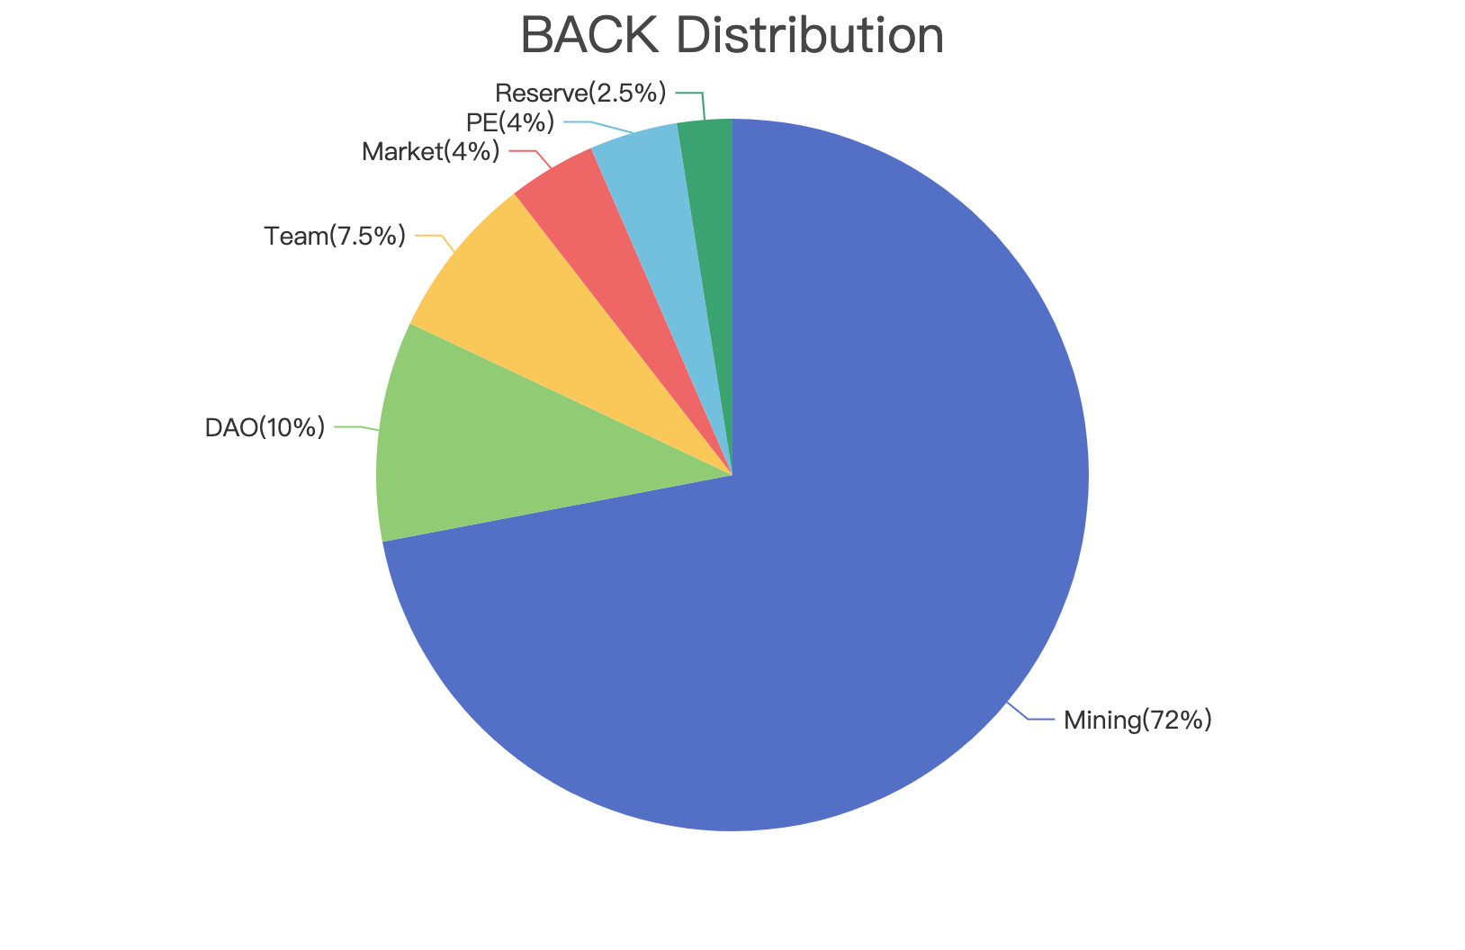

A total supply of 200,000,000

· Liquidity mining 144,000,000 (72%)

· Boardroom (DAO) 20,000,000 (10%)

· Team 15,000,000 (7.5%)

· Market 8,000,000 (4%)

· Private Equity 8,000,000 (4%)

· Reserved for IFO or airdrop (2.5%)

# Risk

Like any borrowing with leverage, BACK FINANCE has its own risk. Below is the outline of some risks each protocol user may face.

**Risks faced by Yield Farmers**

* Yield Farmers(no leverage or in the other words 1x) are exposed to impermanent loss risk.

Note: This is the same risk as participating in other yield farming in AMM pools.

* Leveraged Yield Farmers (more than 1x) also take the risk of being liquidated: liquidation takes place when Debt Ratio (debt / position value) reaches Liquidation Debt Ratio. Liquidation can happen when the value of your collateral drops or the price of your loan increases.

**Risks faced by lenders**

* Lenders share the risk of debts accrued by underwater positions in case liquidators did not liquidate in time. BACK incentivizes liquidators to carry out liquidation in a timely manner by rewarding them with bonuses.

Note: This has not happened before.

* Lenders may delay the deposit withdrawal when fund utilization rate is high. A triple slope interest rate is adopted to improve utilization rate. When utilization rate exceeds 90%, both borrow interest rate and deposit interest rate go up significantly. This encourages borrowers to repay outstanding debts and lenders to make deposits, thus maintaining the pool at the optimal level.

Note: yield farmers can borrow funds as long as they want with no fixed repayment period.

**Contract risk**

* We are doing our best to test our codes. Our codes are open-source and are available for anyone to check.
* A audit by a professional contract auditing firm is underway. Therefore bugs may exist before the audit is finished.

Note: our smart contract is being examined and audited by a third party.